Java Garbage Collection

In java, garbage means unreferenced objects.

Garbage Collection is process of reclaiming the runtime unused memory automatically. In other words, it is a way to destroy the unused objects.

To do so, we were using free() function in C language and delete() in C++. But, in java it is performed automatically. So, java provides better memory management.

Advantage of Garbage Collection

* It makes java **memory efficient** because garbage collector removes the unreferenced objects from heap memory.
* It is **automatically done** by the garbage collector(a part of JVM) so we don't need to make extra efforts.

How can an object be unreferenced?

There are many ways:

* By nulling the reference
* By assigning a reference to another
* By anonymous object etc.

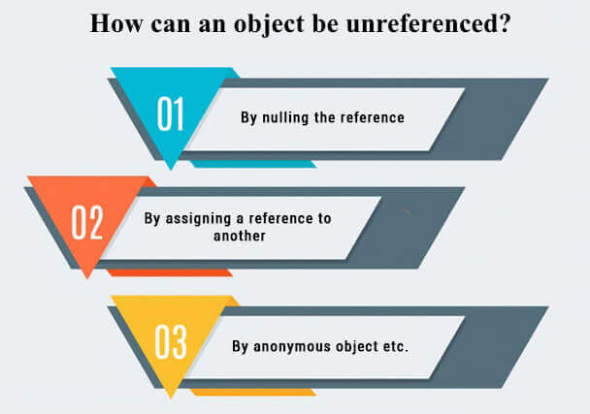

1) By nulling a reference:

1. Employee e=**new** Employee();
2. e=**null**;

2) By assigning a reference to another:

1. Employee e1=**new** Employee();
2. Employee e2=**new** Employee();
3. e1=e2;//now the first object referred by e1 is available for garbage collection

3) By anonymous object:

1. **new** Employee();

finalize() method

The finalize() method is invoked each time before the object is garbage collected. This method can be used to perform cleanup processing. This method is defined in Object class as:

1. **protected** **void** finalize(){}

Note: The Garbage collector of JVM collects only those objects that are created by new keyword. So if you have created any object without new, you can use finalize method to perform cleanup processing (destroying remaining objects).

gc() method

The gc() method is used to invoke the garbage collector to perform cleanup processing. The gc() is found in System and Runtime classes.

1. **public** **static** **void** gc(){}

Note: Garbage collection is performed by a daemon thread called Garbage Collector(GC). This thread calls the finalize() method before object is garbage collected.

Simple Example of garbage collection in java

1. **public** **class** TestGarbage1{
2. **public** **void** finalize(){System.out.println("object is garbage collected");}
3. **public** **static** **void** main(String args[]){
4. TestGarbage1 s1=**new** TestGarbage1();
5. TestGarbage1 s2=**new** TestGarbage1();
6. s1=**null**;
7. s2=**null**;
8. System.gc();
9. }
10. }

**[Test it Now](http://www.javatpoint.com/opr/test.jsp?filename=TestGarbage1" \t "_blank)**

object is garbage collected

object is garbage collected

Note: Neither finalization nor garbage collection is guaranteed.